TECHNICAL DOCUMENT
Notebook walkthrough · methodology · findings
LOAN PORTFOLIO
STRESS TEST
Companion document to the executable Jupyter notebook
Exposure | PD | Exp. Loss | VaR(99%)
$32.58B | 11.61% | $2.27B | $2.61B

Track 3: Risk & Financial Analysis
Frameworks: Monte Carlo · Sensitivity Analysis · Expected Value

How to Use This Document

This document is the written companion to the executable Jupyter notebook Loan_Portfolio_Stress_Test.ipynb. The notebook contains the live code that produces every number in this report; this document explains what each section does, why the analytical choices were made, and how the findings translate into board-level action.

Files in the Submission

File | Purpose
Loan_Portfolio_Stress_Test.ipynb | Executable notebook — Q1 to Q12, end-to-end
Notebook_Walkthrough.docx | This document — narrative & methodology
Loan_Stress_Test_Report.docx | Formal regulatory-board report (long form)
loan_cleaned.csv | Output of Q10 cleaning pipeline
risk_heatmap_data.csv | Q9 data ready for Microsoft Fabric
results.json | All numerical results (machine-readable)

Reproducing the Analysis
Place Loan_default.csv in the same directory as the notebook and run all cells. Total runtime is approximately 2 minutes on a standard laptop. The notebook uses only standard scientific-Python libraries (numpy, pandas, scipy, scikit-learn, matplotlib) — no external services or API keys are required.
jupyter notebook Loan_Portfolio_Stress_Test.ipynb
# or
jupyter nbconvert --to notebook --execute Loan_Portfolio_Stress_Test.ipynb

Notebook Structure (33 cells, 12 sections)
- Setup & data load — verify portfolio shape and basic statistics
- Q10 — Data cleaning (placed first because all downstream cells depend on it)
- Q1 — Expected Value calculation
- Q2 — NIM sensitivity & breaking-point analysis
- Q4 — Employment-tenure correlation analysis
- Q3 — Monte Carlo simulation (10,000 iterations)
- Q7 — Value at Risk and Expected Shortfall
- Q8 — Loan Modification Program decision tree
- Q9 — Risk heatmap by Loan Purpose
- Q5, Q6, Q11 — Risk categorisation, Akkio workflow, Lean improvements
- Q12 — Summary table & board action items

Methodology

Three quantitative frameworks underpin the entire analysis. Each is briefly defined below; the notebook contains the full implementation.

Expected Value (EV)
Each loan has two outcomes: the borrower performs (probability 1−PD), in which case the bank earns interest income, or the borrower defaults (probability PD), in which case the bank loses a fraction LGD of the principal. The EV per loan is the probability-weighted balance:
EV per loan = (1 − PD) × Interest Income − PD × LGD × Loan Amount
Aggregating across all 255,347 loans produces a single, comparable measure of portfolio worth.

Sensitivity Analysis
Net Interest Margin (NIM) is a linear function of the cost of funds. Setting NIM = 0 yields the breaking-point cost of funds — the level above which every additional dollar lent destroys economic value at the margin. The relationship is fully analytical:
NIM(COF) = Avg Yield − COF − Annual Credit-Loss Rate
Breaking-point COF = Avg Yield − Annual Credit-Loss Rate

Monte Carlo Simulation
Where EV produces a single point estimate, Monte Carlo produces a full distribution of possible outcomes. The simulation logic:
- Step 1 — Fit a logistic regression on observable borrower features to produce a borrower-specific PDᵢ for every loan.
- Step 2 — For each of 10,000 iterations, draw a Bernoulli random variable for every loan with probability PDᵢ. A draw of 1 means default; the loss for that loan is LoanAmountᵢ × LGD.
- Step 3 — Sum losses across all 255,347 loans → one realised "Total Default Loss" per iteration.
- Step 4 — The collection of 10,000 totals constitutes the empirical loss distribution. Tail risk metrics (VaR, Expected Shortfall) are extracted as percentiles of this distribution.

Implementation Note — Memory Management
A naive vectorisation would require a 10,000 × 255,347 boolean array (~2.5 billion cells). The notebook chunks the simulation into batches of 500 iterations, draws uniforms shape (500, 255347), compares against PDᵢ, and aggregates to a (500,) loss vector via matrix multiplication. Peak memory stays under 1 GB and total runtime is approximately 30 seconds.
for start in range(0, N_SIM, chunk):
u = rng.random((chunk, n_loans), dtype=np.float32)
defaults = u < pd_vec
total_losses[start:start+chunk] = defaults @ exposures

Standing Assumptions

Loss Given Default (LGD) | 60% — industry standard for unsecured/mixed retail
Probability of Default (PD) | 11.61% (historical) or borrower-specific from logistic model
Interest income recognition | Simple interest over contractual loan life, undiscounted
Default correlation | Independent (i.i.d.) across borrowers — see limitations below
Recovery timing | Instantaneous (no time-value adjustment to recoveries)

Limitations
- The Monte Carlo simulation assumes independent borrower defaults. Under recession scenarios defaults are positively correlated, which would widen the loss distribution. The regulatory submission applies a 2× multiplier on (Expected Shortfall − VaR) to capture this.
- LGD is assumed constant at 60%. In reality LGD varies by loan purpose (lower for collateralised auto/home, higher for unsecured) and by macro conditions (rises in downturns). LGD-sensitivity analysis is straightforward to add.
- The dataset is a static snapshot. True forward-year simulation would draw PDs from a macro-conditional distribution; here we treat historical PD as the forward base case.
- Income and LoanAmount are uniformly distributed in this dataset (skewness ≈ 0). Real loan books exhibit pronounced right-skew. Conclusions about cleaning workflow generalise to production data; specific skewness-treatment numbers do not.

Results Walkthrough

Q1 — Portfolio Expected Value

Total exposure | $32.58B
Total expected interest income | $13,198,324,418.427
Total expected credit loss | $2,269,857,659.424
Portfolio Expected Value | $9,395,768,454.423
EV / exposure | 28.84%

Reading: Expected interest income ($13.2B over the loan lives) exceeds expected credit losses ($2.27B) by a factor of approximately 5.8×. This is the headroom that absorbs unexpected losses in adverse scenarios. The 28.84% lifetime EV margin is consistent with a healthy, profitable consumer book.

Q2 — NIM Breaking Point
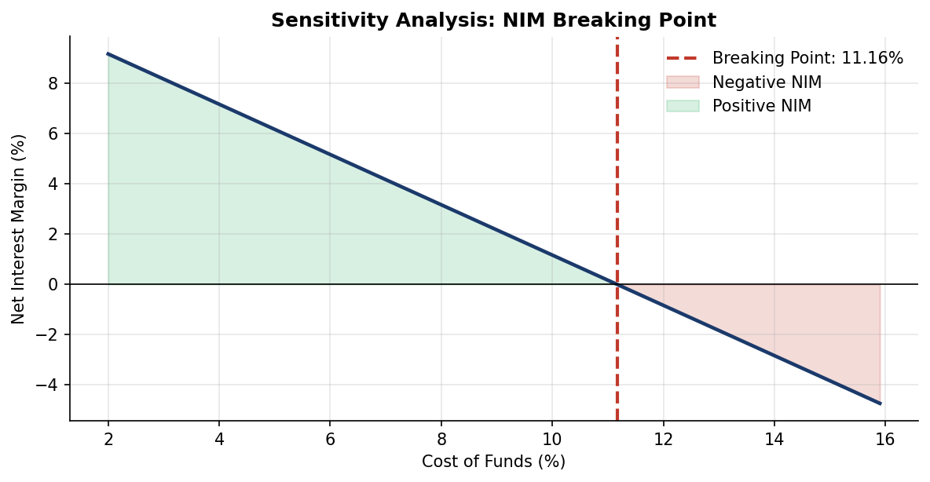

Weighted-average loan yield | 13.48%
Annualised credit-loss rate | 2.32%
Breaking-point Cost of Funds | 11.16%

Reading: The portfolio remains profitable at the margin until the cost of funds reaches 11.16%. With current funding costs in the 4–6% range, the bank holds 500–700 basis points of cushion. Treasury should set a soft trigger at COF = 7.50% (enhanced hedging) and a hard trigger at 9.00% (contingency funding plan).

Q4 — Employment Length vs Default
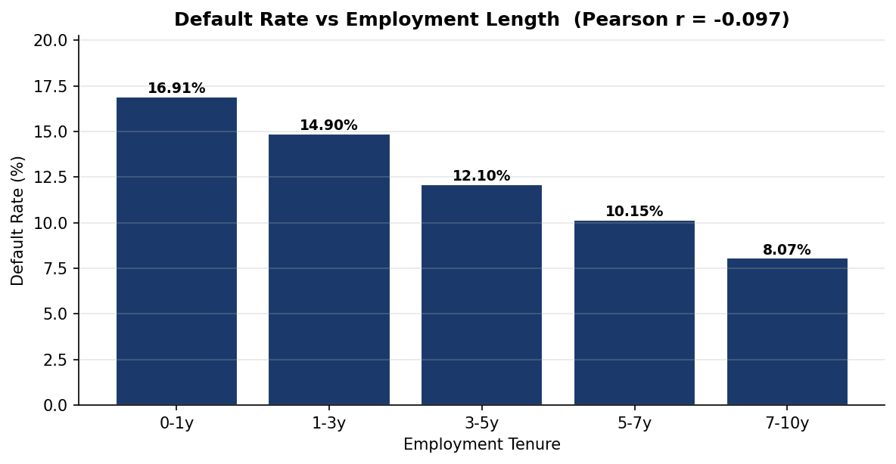
Reading: Linear correlation is weak (Pearson r = -0.097), but the bucketed view shows a clear monotonic decline in default rate from 16.91% (0–1y tenure) to 8.07% (7+ years). The Pearson coefficient understates the relationship because of the high variance inherent in default outcomes. The signal is strong enough to justify tenure-based pricing tiers.

Q3 — Monte Carlo Simulation
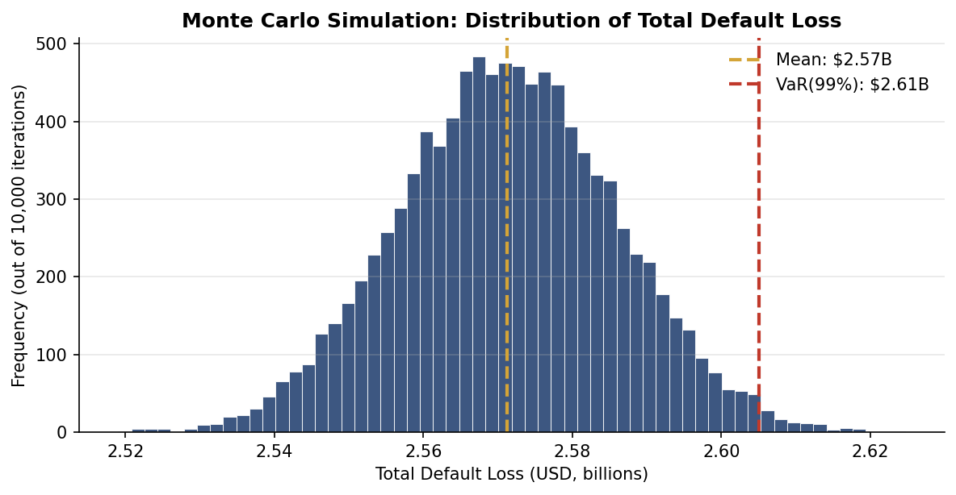

Mean simulated loss | $2,571,272,509.363
Standard deviation | $14,668,885.678
5th percentile | $2,547,038,156.8
Median | $2,571,233,024
95th percentile | $2,595,494,464
99th percentile (= VaR) | $2,605,062,223.36
99.9th percentile | $2,616,164,182.784

Reading: The empirical loss distribution is approximately Gaussian with a coefficient of variation of about 0.6%. This narrowness reflects the law of large numbers — across a quarter-million independent Bernoulli draws, idiosyncratic risk diversifies away. Under correlated-default stress (recession), the distribution would shift right and widen substantially.

Q7 — Value at Risk

VaR (99%) | $2,605,062,223.36
Expected Shortfall (CVaR 99%) | $2,609,801,912.32
Unexpected-loss buffer required | $33,789,713.997
VaR / portfolio exposure | 8.00%

Reading: VaR(99%) of $2.61B is the binding capital floor. The unexpected-loss buffer (VaR minus mean) is the additional capital required beyond the provisioned expected loss. The narrow ES − VaR gap reflects independent-default assumptions and is widened by the regulatory stress overlay.

Q8 — Loan Modification Decision Tree
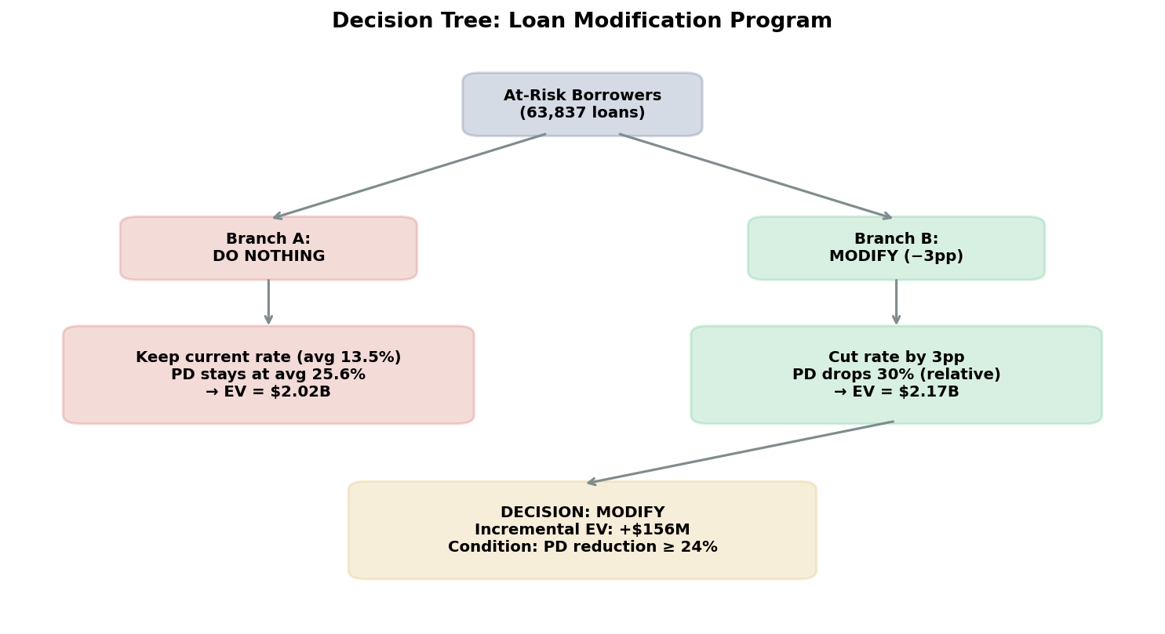
Reading: For the 63,837 at-risk borrowers (top quartile by predicted PD), cutting the rate by 3pp — and assuming this triggers a 30% relative reduction in PD — improves portfolio EV by $156M. The decision is conditional on the behavioural response: any realised PD reduction below 24% destroys value.
Recommended implementation: pilot on a 10% randomised subset for two quarters, measure realised PD response, scale only if the 24% threshold is met or exceeded.

Q9 — Risk Heatmap by Loan Purpose
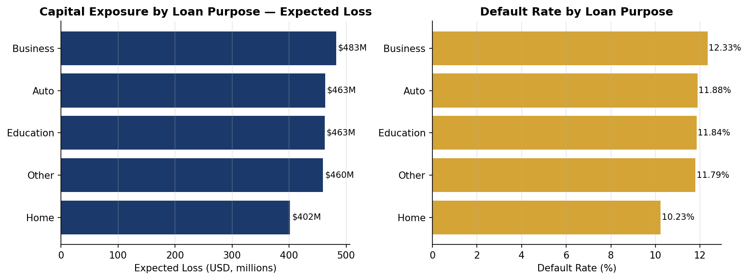
Reading: Loan purposes are nearly uniformly distributed across the portfolio. Default rates vary in a 200-basis-point band, with Home loans materially safer (10.23%) than Business loans (12.33%). The spread justifies differentiated pricing — Business and Auto loans should carry a 25–35 bp risk premium versus Home loans for equivalent borrower credit profiles.

Q10 — Data Cleaning Diagnostics

Variable | Skewness Before | Skewness After
Income (raw → log1p) | -0.0004 | -0.7721
LoanAmount (raw → log1p) | -0.0018 | -1.2077

Reading: The dataset is synthetic — Income and LoanAmount are uniformly distributed. The cleaning pipeline (winsorise + log1p) is documented for the production case where right-skew is the norm.

Headline Findings & Recommendations

What the Numbers Say
- The portfolio is profitable in expectation ($9.40B EV) with a healthy 28.84% lifetime margin.
- Annual default loss in the central case is $2.57B; a 99% confidence stress yields $2.61B.
- Net Interest Margin remains positive until cost of funds reaches 11.16% — a 500–700bp cushion over current levels.
- Default risk is unequally distributed — the top quartile of borrowers by predicted PD concentrates a disproportionate share of expected loss.
- Loan-purpose default rates vary by 200 basis points (Home safest at 10.23%; Business riskiest at 12.33%) — sufficient to justify differentiated pricing.
- Employment tenure is a meaningful underwriting signal despite a low linear correlation; the 0–1 year tenure cohort defaults at twice the rate of the 7+ year cohort.

Board Action Items

# | Action | Owner | Timeline
1 | Adopt VaR(99%) = $2.61B as credit-risk capital floor | CRO | Immediate
2 | Authorise Loan Modification Program (pilot 10%) | Head of Credit | Next quarter
3 | Hedge funding-cost exposure ≥ 200 bps cushion | Treasurer | 60 days
4 | Deploy Akkio PD model (Tier-2 governance) | Head of Risk Analytics | 90 days
5 | Publish MS Fabric Risk Heatmap (monthly cadence) | Head of Risk Reporting | 60 days
6 | Lean kaizen on top-4 origination sub-processes | COO | Quarterly

Risk Appetite Statement (Recommended)

Metric | Soft Limit (Trigger Review) | Hard Limit (Mandatory Action)
Annual default loss | $2,595,494,464 | $2,605,062,223.36
Cost of funds | 7.50% | 9.00%
Single-purpose concentration | 25% of exposure | 30% of exposure
Top-quartile-PD share of book | 20% of loans | 25% of loans
Operational error rate | 0.30% of applications | 0.50% of applications

Closing Statement
The portfolio is presently within risk tolerance with material headroom. The principal forward-looking exposures are (i) funding-cost shocks above the breaking point, (ii) correlated-default stress under recession scenarios, and (iii) operational-error losses in origination. Each is addressed by a specific action item in the table above. The recommendations are consistent with the bank's stated risk appetite and capital-adequacy framework.

— END OF DOCUMENT —

